**BX3194: DESTINATION MANAGEMENT AND PLANNING**

ASSESSMENT TASK 2 COLLEGE OF BUSINESS, LAW AND GOVERNANCE

**GROUP TASK COVER SHEET**

|  |  |  |  |  |  |  |  |  |  |
| --- | --- | --- | --- | --- | --- | --- | --- | --- | --- |
| *Students*  *Please sign, date and attach cover sheet to front of assessment task for all hard copy submissions* | | | | | | | | | |
| **SUBJECT CODE** | BX3194 | | | | | | | | |
| **STUDENT FAMILY NAME** | **Student Given Name** | **JCU Student Number** | | | | | | | |
| Tran | Le Binh | 1 | 3 | 4 | 7 | 6 | 1 | 1 | 2 |
| Chen | Zhiqing | 1 | 3 | 3 | 7 | 4 | 9 | 4 | 0 |
| **ASSESSMENT TITLE** | Signature Event/Tourism product Report | | | | | | | | |
| **DUE DATE** | 10/09 2018 | | | | | | | | |
| **LECTURER NAME** | Pamela Wildheart Pilapil | | | | | | | | |
| **TUTOR NAME** | Pamela Wildheart Pilapil | | | | | | | | |
| **Student Declaration**   1. This assignment is our original work and no part has been copied/ reproduced from any other person’s work or from any other source, except where acknowledgement has been made (see *Learning, Teaching and Assessment Policy 5.1*). 2. This work has not been submitted for any other course/subject (see *Learning, Teaching and Assessment Policy 5.9*). 3. This assignment has not been written for us. 4. We hold a copy of this assignment and can produce a copy if requested. 5. This work may be used for the purposes of moderation and identifying plagiarism. 6. We give permission for a copy of this marked assignment to be retained by the College for benchmarking and course review and accreditation purposes.   [Learning, Teaching and Assessment Policy](http://www.jcu.edu.au/policy/allitoz/JCU_076643.html) 5.1. A student who submits work containing plagiarised material for assessment will be subject to the provisions of the [Student Academic Misconduct Requirements.](http://www.jcu.edu.au/policy/allitoz/JCUDEV_005375.html)  **Note definition of plagiarism and self plagiarism in Learning, Teaching and Assessment Policy:**  **Plagiarism:** reproduction without acknowledgement of another person’s words, work or expressed thoughts from any source. The definition of words, works and thoughts includes such representations as diagrams, drawings, sketches, pictures, objects, text, lecture hand-outs, artistic works and other such expressions of ideas, but hereafter the term ‘work’ is used to embrace all of these. Plagiarism comprises not only direct copying of aspects of another person’s work but also the reproduction, even if slightly rewritten or adapted, of someone else’s ideas. In both cases, someone else’s work is presented as the student’s own. Under the Australian *Copyright Act 1968* a copyright owner can take legal action in the courts against a party who has infringed their copyright.  **Self Plagiarism:** the use of one’s own previously assessed material being resubmitted without acknowledgement or citing of the original. | | | | | | | | | |
| **Student signature(s)**  Tran Le Binh Submission date 10/09 2018  Chen Zhiqing Submission date 10/09 2018 | | | | | | | | | |

**TABLE OF CONTENT**

**1. Introduction 4**

**2. Summary of visitors and event attendees 5**

**2.1. Summary of visitors to Singapore 5**

**2.1.1. Overall visitors 5**

**2.1.2. Chinese visitors 8**

**2.2. Profile of event attendees in Singapore 10**

**2.2.1. Demographics segmentation 10**

**2.2.2. Psychographics segmentation 10**

**2.2.3. Target market selection: 10**

**3. SWOT analysis 11**

**4. Signature Event Concept 13**

**4.1. Attracting New Visitors to the Region and/or Encouraging Visitors to Stay Longer 17**

**4.2. Consistency with Singapore Tourism Board’s Tourism Brand and Contributes to Existing Event Calendar 18**

**4.3. Builds on / Leverages Existing Destination Assets and Infrastructure 19**

**4.4. Positive Contributions and Local Community Capital 19**

**APPENDIX**

Figure 1: International Visitor Arrivals from January to March in 2018 6

Figure 2: Top 15 countries for tourist arrivals from January to March in 2018 6

Figure 3: The top five countries for tourist spending from January to September in 2017 7

Figure 4: Tourist sector performance in terms of tourism receipts 8

Figure 5: China’s Visitor Arrivals, Tourism Receipts and Purpose of Visit 8

Figure 6: Tourism Receipts and Shopping Items in Singapore 9

Figure 7: The breakdown of Chinese tourists’ behaviors in terms of information resources 9

Figure 8: A number of Internet Users in China, 2006-2017 10

Figure 9: “Old is Gold” Day 1 host place 14

Figure 10: “Old is Gold” Outdoor concert 14

Figure 11: “Old is Gold” Opening Ceremony Guest List 15

Figure 12: “Old is Gold” Performing Activities 15

Figure 13: “Old is Gold” Design Sketch 16

Figure 14: “Old is Gold” Heritage Exhibition 17

Figure 15: “Old is Gold” Exhibition 17

# Introduction

Singapore locates near the equator which makes the country feel summer all the year round (Seah, 2018). Therefore, the weather of Singapore contributes the higher level of competitive advantage than other countries. Singapore has a great reputation, which is known as the Garden City Singapore where the flowers, tall shady trees and lushes are cultivated along the central part of the expressways and around public spaces. Singapore is considered as the cleanest city and the strict laws system in the world (Seah, 2018). In 2017, Singapore become the second safety city in the world (Coconuts Singapore, 2017). These are the reasons why Singapore has become the second most visited destination in the Asia-Pacific region and the top in the tourists’ expenditures (Hui, 2017). In Singapore, tourists can achieve the greater aesthetic fulfillment, enhance the high level of destination experiences and satisfaction by discovering the nature, cultures, cuisines, unique buildings created by human hands. For example, visitors can experience the natural environment at the Botanic Garden, Singapore Zoo or Garden by the Bay, the paradise of culture and cuisines in the vicinity of Chinatown, Little India, Geylang or Haji Lane. For the stunning landscape, they are around Clarke Quay, Fountain of Wealth, Buddha Tooth Relic Temple and Museum, Henderson Waves Bridge, Marina Bay Sands, Merlion Park, Esplanade – Theatres on the Bay, ArtScience Museum and Singapore Flyer. For the entertainment, people can visit Sentosa Island where there are several interesting venues such as Universal Studios Singapore, Skyline Luge Sentosa, iFly Singapore, S.E.A Aquarium, Trick Eye Museum Singapore, etc. For contemplating the knowledge of biophilic design, people can visit the Park Royal hotel, the Oasia Hotel Downtown. The visitors can actively participate in these amazing places to enhance their destination experiences due to the fact that Singapore has been possessing the top eighth urban transport system of 100 cities around the world (Stolarchuk, 2017).

The two major events in Singapore are the Formula One Singapore and the Singapore Airshow. In 2017, the Formula One Singapore Grand Prix helped the enhancement of Singapore’s image as an innovative and vibrant city and attracted more than 450,000 international visitors, which contributes around $1.4 billion of tourism receipts (Meng, 2017). In 2018, the Singapore Airshow attracted more than 80.000 visitors (Ho, 2018). Thanks to this events, Singapore is known as the world leading technological hub and Asia’s center of technological innovation (Koumelis, 2018). Another major event is called Singapore Food Festival, which has been celebrating for over 25 years. In 2018, the theme of Singapore Food Festival is “Savour Singapore in Every Bite”, which emphasized the food heritage generations to envelope on Singaporean cuisine and the culinary creations (Singapore Tourism Board, 2018). The cuisine makes Singapore become one of the world’s most fascinating food destinations (Food and Wine, 2018). Overall, the event industry makes a positive contribution to economic, social, cultural capital for the local economy (Deng, 2013). Singapore aims to create signature events to draw the attention from specific target audiences and to understand the demand of target market (Ali-Knight, 2008). These famous events become the major competitive advantage to attract more Chinese people.

During the first quarter of 2018, the tourist arrivals is up to 7.1% due to the effort of advertising from Singapore Tourism Board (Thenewpaper, 2018). Currently, there are about 24 Regional Offices and 4 Marketing Representatives over 7 regions so that Singapore Tourism Board can perform the function of promoting and marketing tourism industry (STB, n.d). Singapore Tourism Board collaborates with other tourism industries to innovate and create value for visitors (Singapore Tourism Board, 2017). One of the most visitors travelling to Singapore belongs to China, which was recorded as nearly 1 million (Singapore Tourism Board, 2018). It is important to notice that the payment method is the outstanding concern for Chinese people when they travel (Thet, 2018). In order to increase a large amount of Chinese citizens, Singapore Tourism Board has cooperated with Alipay to solve the issue of payment mode when they visit Singapore (Thet, 2018). The creation of signature events will make Singapore attract more international tourist and becomes the manpower demand in the tourism industry (Soh, 2008). This will create the multiplier effect between the tourists and the local economy. There are some pull factors that Chinese people visit Singapore. Firstly, Singapore has a great reputation as one of the safest nations in the world. Secondly, there is the Singapore’s relaxation of visa regulations for Chinese nationals in 2015. Next, Singapore possesses an attractive heritage, cultural diversity and the world-class tourist destinations availability. Then, there are Mandarin language and food, which enhance the satisfaction level of travelling to Singapore for Chinese people (Lee, 2017).

The study investigates that most Chinese people travelled with their relatives or families (Kau & Lim. 2005). For Singapore’s demographic, there are about 74.3% of Chinese groups, 36.3% and 4.1% of Mandarin and Cantonese languages used (Index Mundi, 2018). Most of Chinese people in Singapore have their ancestors who were Chinese people in Mainland China so that Chinese people in China and Singapore have similarities about languages, food, religion. To draw attention about Chinese ethnic group between two countries, there is a signature event with the theme “Old is Gold”. The concept of the event is to form the intimate relationship of Chinese people between Singapore and China by using the ancient characteristics of China’s heritages when Chinese people visit Singapore.

# Summary of visitors and event attendees

#### Summary of visitors to Singapore

##### Overall visitors

In 1st quarter of 2018, Singapore’s International Visitor Arrivals are around 4.6 million, which is describe in Figure 1 (Tourist sector performance, 2018).

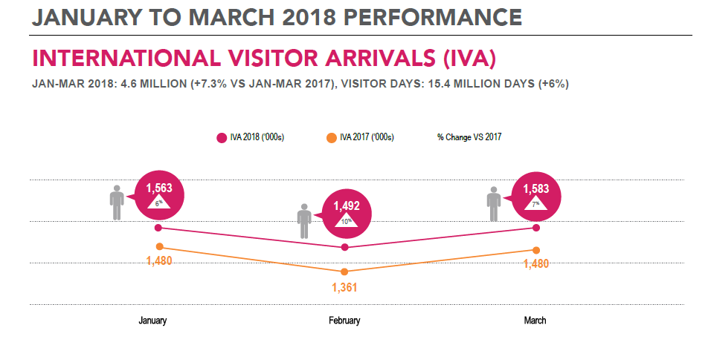

Figure 1: International Visitor Arrivals from January to March in 2018

The top five countries for tourist arrivals are China, Indonesia, India, Malaysia and Australia, which is described in Figure 2 (Tourist sector performance, 2018).

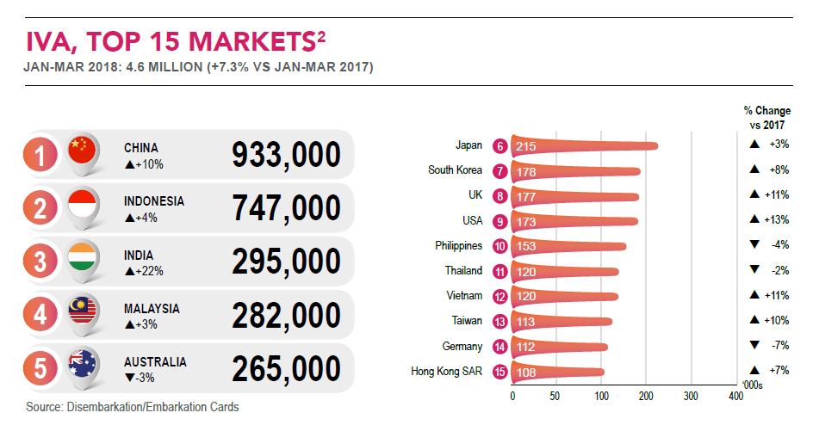

Figure 2: Top 15 countries for tourist arrivals from January to March in 2018

The top five countries for tourist spending when they visit Singapore are China, Indonesia, India, Australia and Japan, which is provided by the Figure 3 (Tourist sector performance, 2018).

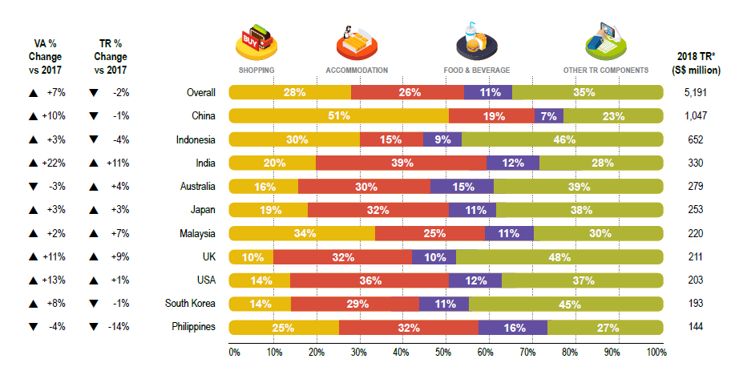

Figure 3: The top five countries for tourist spending from January to September in 2017

For the tourist performance in terms of tourism receipts, the field of shopping, accommodation, food and beverage decreased by 9%, 13% and 16%, respectively. The sector of sightseeing, entertainment & gaming and other tourism components increased by 6% and 22%, respectively, which is described by Figure 4 (Tourist sector performance, 2018).

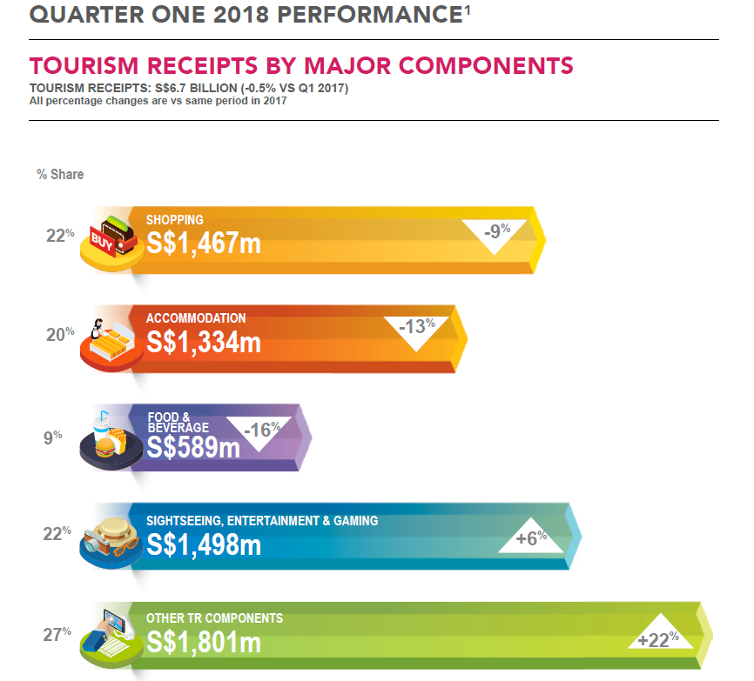

Figure 4: Tourist sector performance in terms of tourism receipts

##### Chinese visitors

During the first quarter in 2018, Singapore welcomed about 10 million tourists around the world. For China market, there are about 2 million visitors (Singapore Tourism Board, 2018). According to Figure 5, the purposes of visit Singapore are visiting friends or relatives, holidays, businesses or MICE and others (STB Market Insights – China, 2013).

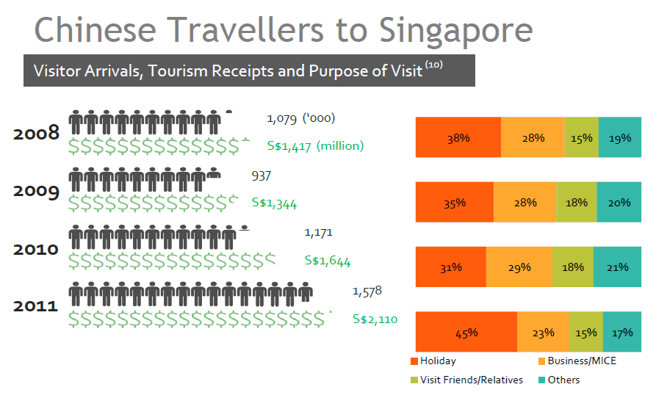

Figure 5: China’s Visitor Arrivals, Tourism Receipts and Purpose of Visit

China’s tourism receipts belong to shopping, accommodation, F&B, transportation. The regular items for shopping in Singapore are fashion and accessories, watches and clocks and genuine jewelry, which is provided by Figure 6 (STB Market Insights – China, 2013). As a result, there are top five leisure activities for Chinese people such as go shopping, visit a famous landmark or tourist icon, go to a casino, visit a nature or animal-related attraction or visit a museum or gallery (STB Market Insights – China, 2013).

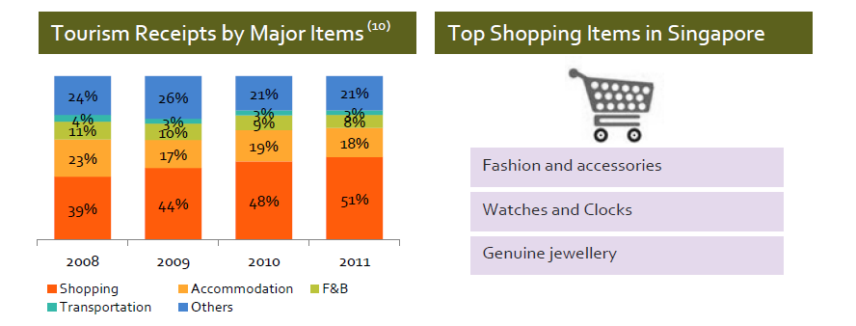

Figure 6: Tourism Receipts and Shopping Items in Singapore

Before travelling to the destination, Chinese people tend to find the information from online sources, travel agent, recommendation from previous visitors, travel guidebook, specialist travel magazine or newspaper. During travelling to the desire destination, they depend on the information resource from brochures picked up at destination, travel guidebooks, online sources, tour guide and maps (STB Market Insights – China, 2013). The breakdown of Chinese tourists’ behaviors in terms of information resources is described in Figure 7.

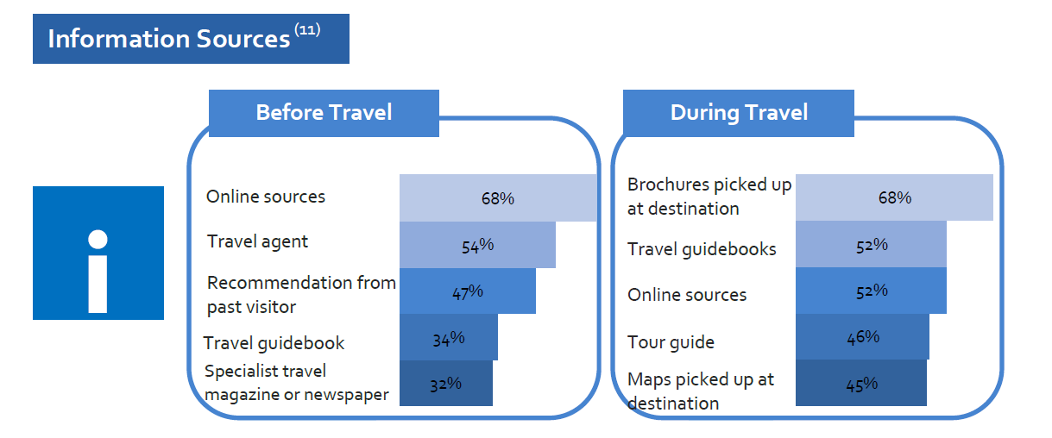

Figure 7: The breakdown of Chinese tourists’ behaviors in terms of information resources

More than 0.7 billion of Chinese people has used the Internet, which is described in Figure 8 (Statista, 2018). Hence, they visit online travel review sites such as “Mafengwo”, “Daodao”, “Ivmama” where the suggested sights with pictured are provided by previous travelers. Chinese people uses travel search engines such as “Ctrip” and “Qunar” to find the flights details and accommodations (STB Market Insights – China, 2013).

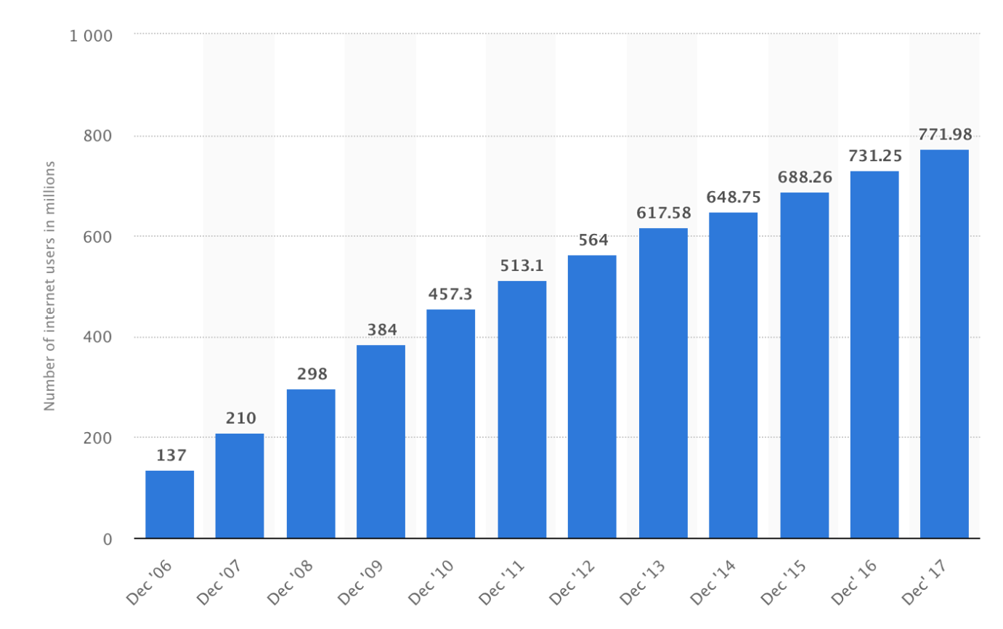

Figure 8: A number of Internet Users in China, 2006-2017

#### Profile of event attendees in Singapore

###### Demographics segmentation

* People from China, aims to attract 1 million of Chinese people
* Males and females
* 1 to 80 years-old
* Estimated household size of 2 to 8 members
* Any marital status and ethnicity
* Working professional – mainly white-collar workers, retirees and students including children in the family
* Middle to high income
* Any education background

###### Psychographics segmentation

* Have an attitude of taking a break from work and school to rejuvenate themselves.
* Have interests and hobbies that appreciate the Chinese heritages, food and music
* Enjoys an active lifestyle, seek to relax during leisure time
* Seeking unique and exotic experiences towards the signature event
* Connect with relatives in Singapore to participate in the signature event

###### Target market selection:

* The main target markets are young families with children under 5 in the household, SINKS/DINKS aged 18-49 with no children in the household, elderly people, social groups (travelling with friends), couples, empty nesters aged over 50 with no children in the household and MICE.
* The determination of target market benefits to the event organization to deliver appropriate quality services and products

# SWOT analysis

|  |  |
| --- | --- |
| **Strengths**   * “Old is Gold” event is hosted in Singapore where there is an attractive place for Chinese people. * The event is celebrated at Marina Bay Sands, Chinatown, Orchard Road, which are the well-known attractions in Singapore. * The event uses Mandarin and English to avoid language barriers for Chinese tourists. * The event provides the wonderful opportunity to remind and advertise the Chinese heritages for international communities and Chinese ethnic groups in Singapore. * Visitors can visit the event venue by using bicycles, traditional taxi or GRAB, public transportation like MRT, bus. * The event is hosted in the safest country in the world. * The visitors form a relationship with Singaporeans. * The visitors enjoy the largest Chinese buffet. * The visitors find exotic products like ancient music, natural medicine, diversity of food from other Chinese provinces. * The event educates the children and adults about the cultural heritage of mankind. * The event offers different souvenirs according to the theme. * The visitors take several photos with stunning decorations to capture valuable moments. * The event improves the diplomatic relations between two countries. | **Weaknesses**   * The event does not attract adults due to the event of heritages. * The event encounters the problem of excessive carrying capacity due to a large number of Chinese people. |
| **Opportunities**   * The event enhances destination image of Singapore. * Marina Bay Sands, Chinatown, Orchard Road are promoted in the higher level. * More visitors from other countries are interested in the event such as Hong Kong, Vietnam, Europe, Thailand, etc… * The more visitors participate in the event, the more revenue and benefit Singapore Tourism Board earns. * The event is advertised freely through the word-of-mouth from visitors and netizens. * Some works about music, food and other Chinese heritages is achieved as the higher level of appreciation. * The event venue is in close proximity to entertainment places like casino, shopping malls, food court. * Visitors enjoy the non-pollution atmosphere when visiting the event venue. * The event offers new experiences and knowledge from Western countries about China’s inventions. * There are direct flights from China to Singapore, which makes convenience for Chinese people to visit Singapore. | **Threats**   * Some event venues are hosted outdoor, which is easily affected by the weather conditions. * Chinese people encounter the concern about visa when they visit Singapore so that there will be a limited number of Chinese people attending the event. * There will be fierce competition from other countries due to the fact that there are some major events hosted in other countries. * The event message is destroyed due the rude and uncivilized behavior of Chinese people (Phneah, 2017). |

# Signature Event Concept

The event is called "Old is gold", which will be held on 5th August and 7th August. There are three main themes according to the three days of the event. The first day which is on 5th August will exhibit traditional Chinese art as the theme, which provides the platform for visitors to experience the traditional Chinese music, opera, and martial art. The show will be held in the Marina Bay Sands Event Plaza, where is located in the center of the Marina Bay Sands presenting the central piece of Singapore's Urban Transformation (Marina Bay, n.d.). Generally, this vibrant place often hosts variety forms of entertainment from concerts to festivals and it is convenience for Chinese people to visit Art-Science Museum, Casino, Marina Bay Sands Hotel by walking short distance. The event venue is demonstrated in Figure 9. This place is suitable for outdoor concerts, which is demonstrated in Figure 10.

The agenda of Day One begins with the rituals of opening ceremony. The current Prime Minister of Singapore names Lee Hsien Loong and the President of the People’s Republic of China named Xi Jinping will give an opening speech. Then, the event will then officially begin with the performance of the first lady of China-Peng Liyuan who is a musician. She will be specially invited for playing traditional instruments – Zither. Some famous Chinese and Singapore’ actors and singers will be invited to the red carpet, which is provided in Figure 11. There is a list of Singaporean and Chinese artists jointly performing Chinese Opera, Chinese Traditional Music and Chinese Martial Art such as Wushu, Kungfu, Shaolin Bai He Quan, Taijiquan, Chikung, Wing Chun Kuen, which is provided in performing activities see Figure 12.

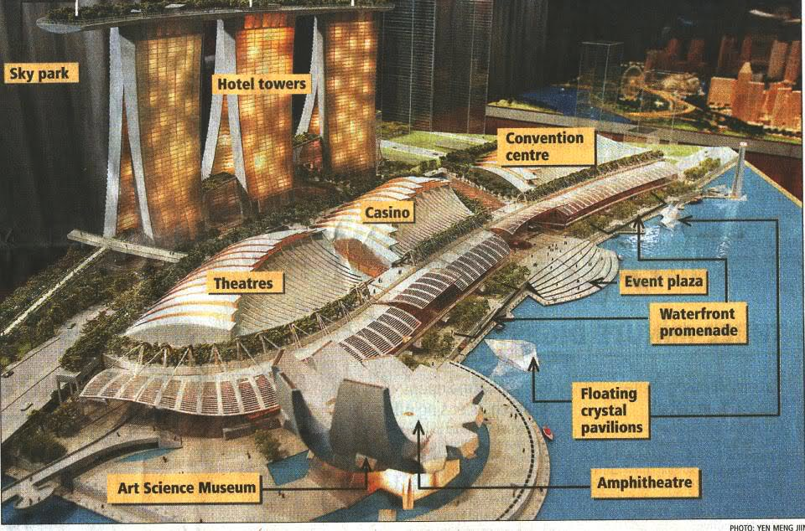

Figure : “Old is Gold” Day 1 host place

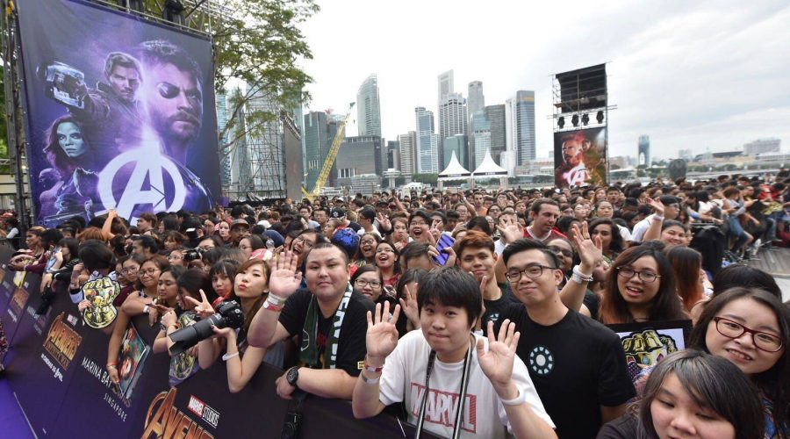

Figure : “Old is Gold” Outdoor concert

|  |  |  |  |
| --- | --- | --- | --- |
| **Singapore** | | **China** | |
| **Actor** | **Singer** | **Actor** | **Singer** |
| Aaron Aziz | Stefanie Sun | Zhang Ziyi | Jay Chou |
| Adam Chen | JJ Lin | Stephen Chow Sing Chi | A-Mei |
| [Adrian Pang](https://www.ranker.com/review/adrian-pang/404086?ref=node_name&pos=3&a=0&ltype=n&l=161641&g=1) | By2 | Jackie Chan | Jolin Tsai |
| [Addy Lee](https://www.ranker.com/review/addy-lee/400885?ref=node_name&pos=4&a=0&ltype=n&l=161641&g=1) | [A-do Do](https://www.ranker.com/review/%E9%98%BF%E6%9D%9C/386229?ref=node_name&pos=1&a=0&ltype=n&l=166402&g=2) | Jet Li | Cui Jian |
| [Aileen Tan](https://www.ranker.com/review/aileen-tan/412636?ref=node_name&pos=5&a=0&ltype=n&l=161641&g=1) | Arif | Gong Li | Faye Wong |
| [Allan Wu](https://www.ranker.com/review/allan-wu/435358?ref=node_name&pos=9&a=0&ltype=n&l=161641&g=1) | [Hanwei](https://www.ranker.com/review/chen-hanwei/710883?ref=node_name&pos=4&a=0&ltype=n&l=166402&g=2) Chen | Donnie Yen | Jacky Cheung |
| Andrew Seow | [Corrinne May](https://www.ranker.com/review/corrinne-may/777124?ref=node_name&pos=5&a=0&ltype=n&l=166402&g=2) | Maggie Cheung | **Andy Lau** |
| [Ang Ching Hui](https://www.ranker.com/review/ang-ching-hui/465516?ref=node_name&pos=12&a=0&ltype=n&l=161641&g=1) | Joi Chua | Crystal Liu | **Leehom Wang** |
| [Annabel Chong](https://www.ranker.com/review/annabel-chong/467129?ref=node_name&pos=15&a=0&ltype=n&l=161641&g=1) | [Elsa Lin](https://www.ranker.com/review/elsa-lin/931585?ref=node_name&pos=10&a=0&ltype=n&l=166402&g=2) | Charmaine Sheh | **Aaron Kwok** |
| Ase Wang | [Inch Chua](https://www.ranker.com/review/inch-chua/62025114?ref=node_name&pos=12&a=0&ltype=n&l=166402&g=2) | Michelle Yeoh | **Wakin Chau** |
| [Ava Lyn Koh](https://www.ranker.com/review/ava-lyn-koh/517091?ref=node_name&pos=18&a=0&ltype=n&l=161641&g=1) | [Fann Wong](https://www.ranker.com/review/fann-wong/976681?ref=node_name&pos=13&a=0&ltype=n&l=166402&g=2) | Vicki Zhao | **Wilber Pan** |

Figure : “Old is Gold” Opening Ceremony Guest List

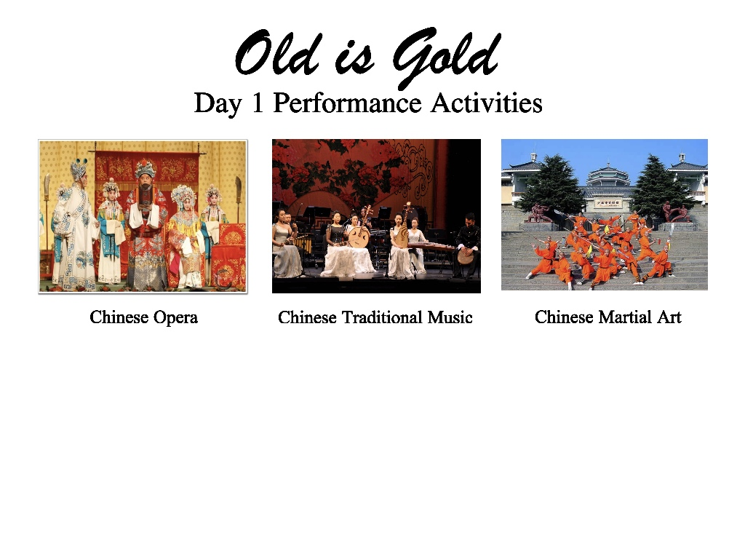

Figure : “Old is Gold” Performing Activities

On 6th August, the event theme is cuisine. The event will focus on Chinese cuisine and provide the world's largest buffet for Chinese cuisine. The event locates at the Chinatown area and there is not any traffic on Day Two in the vicinity of event area. Chinatown will display of the Chinese traditional kitchen and tea ceremony. There are some food stalls to provide Chinese cuisine such as Dim Sum, Hotpot, Porridge, Bao, Noodles, Chinese Soup, Dumpling, Special Dishes such as Fried Rice, Sugar-Coasted Haws, Char Siu, Steamed Chicken, Roasted Pork, Tingky Tofu, Sweet and sour Ribs, Ma Fo Tofu, Pan-Fried Spring Rolls, Fish-Plavored Pork, Chinese Hamburger, Zha Jiang, Fried Bread Stick. There will have the delicacy of all decorations with traditional Chinese style. People have zero-distance contact to experience Chinese food, which is provided by Figure 13.



Figure : “Old is Gold” Design Sketch

On 7th August, the event characterizes Chinese heritages by creating an ancient street. The event will locate on Orchard road, which is the main road center of Singapore with the main shopping areas (A Great Street, n.d.). over the course of the day, the Orchard Road will have the features of ancient China, which is demonstrated in Figure 14. Moreover, there are some stalls providing the service of wearing different types of dynasties outfits such as the dynasty of Tang, Han, Ming and Qing. Visitors can rent and buy clothes to experience the feeling of traveling through the ancient times.

There is an exhibition including the iconic models, traditional medicine, the four ancient Chinese inventions, which is demonstrated in Figure 15. The iconic models are Great walls of China, Panda, Tiananmen Square, The Forbidden City, Summer Palace, Mausoleum of the First Qin Emperor, Confusius, china, calligraphy, Chinese fan, silk, abacus and paper umbrella. Traditional medicines are acupuncture and herbal. The four ancient Chinese inventions are Printing Technique, Papermaking, Gunpowder, Compass. It is interesting to notice that during the ancient Chinese Song Dynasty, people regarded women's small feet as beauty. Since then, there has been a custom of binding feet (Foreman, 2015). The event will show ancient Chinese shoes while introducing history. Visitors can experience the moment of wearing small shoes. If any visitors fit the shoes dimension, they can take them away and earn rewards.

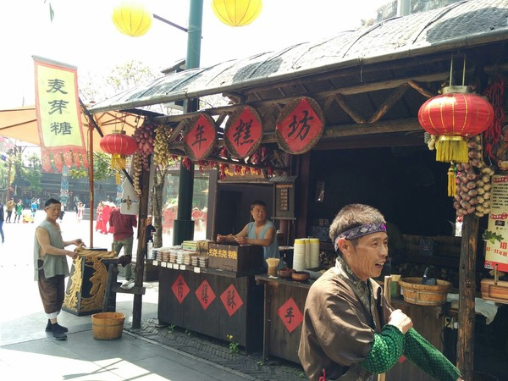

Figure : “Old is Gold” Heritage Exhibition



Figure : “Old is Gold” Exhibition

### Attracting New Visitors to the Region and/or Encouraging Visitors to Stay Longer

The study found that the greatest motivation for tourists to participate in festivals or activities included escape, watching, content specialization, socialization, event experience and family sharing opportunities (Cravens, 1994). This activity meets six requirements. First of all, the event has profound social and educational significance from the visual and content. It combines art performances, food and historical objects, leading tourists to review Chinese history and heritages. Secondly, the main target markets are young families with children under 5 in the household, SINKS/DINKS aged 18-49 with no children in the household, elderly people, social groups (travelling with friends), couples, empty nesters aged over 50 with no children in the household and MICE. The event attracts new visitors and a large number of Chinese tourists. 15% of young Chinese travel with older family members, 34% with children. Because the event will be held in mid-August, which is a summer vacation for Chinese students (China Tourism Facts & Figure, 2018). The event provides the opportunity of exchanging culture, languages and heritages for Chinese ethic of both countries so Chinese people from mainland China will spend more time in Singapore to explore the similarities and differences about the culture between two countries.

### Consistency with Singapore Tourism Board’s Tourism Brand and Contributes to Existing Event Calendar

STB and EDB launched a unified brand - Singapore-Passion Made Possible, which presents Singapore with a passionate, never-ending determination and entrepreneurial spirit, a unique attitude and mentality of continuing to pursue possibilities and remodeling and the use of Singapore's international market for tourism and business purposes (Marketing Singapore, n.d.).

This Passion Made Possible brand is based on three basic principles, transcending the unified brand of tourism, from the inside out approach and standing in one attitude and belief (Marketing Singapore, n.d.). The Unified Brand Beyond Tourism aims to convey the nation's value propositions in meeting the needs of travelers and companies. "Old is Gold" event draws visitors who seek to immerse themselves in culture and establish deeper ties with their destinations by focusing on Chinese heritages.

Secondly, an internal-external approach is essential to transcend tourism and build a true and authentic Singapore brand. "Old is Gold" event puts consumers at the center of the brand process and starts with a country - China process that drives the possibility of Chinese tourists. Sticking to an attitude and belief means that the brand will build affinity and ties with Singaporeans and residents. Since ethnic Chinese make up 76.2% of Singapore's citizen population (Singapore Demographics Profile, 2018). The "Old is Gold" event will also attract Singaporeans to participate and promote, which will bring Chinese and Singaporean tourists together to participate in activities and share their experiences, leading to the creation of social networks.

The "Old is Gold" event will contribute to the existing Calendar of events while maintaining consistency with the tourism brand of the Singapore Tourism Authority. Since the event will be held from August 5 to 7, and then on August 9, Singapore's annual National Day, the most important day of the year, tourists will extend their travel to more kinds of events, and this is also the best time to show Singapore's style (National Day, n.d.). In addition, there is a Hungry Ghost Festival starting on August 11, which is a completely different type of activity from our activities. Visitors can soak in local culture and observe the traditional rituals of ultra-modern Singapore through this festival (Isadora, 2018). In collaboration with STB, the event activities can contribute to the existing Calendar of events and better facilitate the participation of visitors in other upcoming activities in Singapore. The short intervals between these events will enable visitors to better understand and stimulate their interests and extend their travel time.

### Builds on / Leverages Existing Destination Assets and Infrastructure

Tourism infrastructure involves methods of transportation, preservation or protection of natural resources, natural construction of the environment and provision of legal services, recreational facilities and infrastructure (Middleton & Hawkins, 1998). Destination assets and infrastructures are important because they are one of the key factors contributing to the growth of the number of tourists. It is interesting to notice that Singapore has been possessing the top eighth urban transport system of 100 cities around the world (Stolarchuk, 2017). Before the event is celebrated, Singapore infrastructures and assets are examined carefully to ensure that the event will be conducted in an expeditious way. The visitors access the event venues easily by using public transportation. More than 350 flights are conducted from more than 20 airports in China (STB Market Insights – China, 2013). Therefore, the STB will cooperate with airlines, public transportation travel agencies to advertise and broadcast the event their company websites or stations. The event information is provided to tourists from the generating regions to the destination regions.

It is crucial to examine in the vicinity of events to ensure that visitors visit both the event venue and other attractions in Singapore. For example, on day 1, the event will be held in Marina Bay Sand which is which is near the Gardens by the Bay. Gardens by the Bay is one of the most important gardening destinations for development and management in Asia (Our Story, n.d.). The green area also the factors that Chinese tourists are looking for. It is important to take advantage of these assets. The event will provide a guidebook with walking routes to guide visitors to the Gardens by the Bay if tourists want to explore more about Singapore island.

In addition, events can be built on existing destination assets and infrastructures, such as food or shopping places. Shopping is one of the main factors affecting the choice of destination in China and is the highest proportion of tourists spending in Singapore (STB Market Insights – China, 2013). Orchard Road is an event venue on the third day. Chinese visitors combine the experiences between the event discovery and shopping. This will help Singapore create more revenue while promoting its infrastructure festivals.

### Positive Contributions and Local Community Capital

The study found that the events have direct and indirect impacts on communities and promote the development of local communities in different aspects of capital (Alves et al, 2010). The event makes a positive contribution to Singapore in terms of built, human, political capital and the well-being of local communities. The positive impact on human capital is that with the "Old is Gold" event brings about employment opportunities for local community in other tourism industries such as hotels, airlines, food and beverages. The event attracts professional employees from marketing and accounting. For marketing, people will conduct several advertising activities like press release, press conference and facilities provision to visit. For accounting field, a large number of people will calculate from the event. In terms of political capital, as the event focuses on Chinese heritages, it will enhance the diplomatic affairs between Singapore and China. In terms of built capital, it includes the availability of machinery, transportation infrastructure, human artifacts and services to meet human needs like shelter, subsistence, mobility and communications (Costanza, 2012). The event requires the availability of Marina Bay Sands, Chinatown, Orchard Road, public transportation, human decorations to enhance the satisfaction level.

Event provides positive impact on cultural capital by solving the demand for the culture, improving the venue infrastructures, stimulating local creativity and animating local involvement (Liu, 2012). The local cuisine is upgraded by combining the Mainland Chinese flavor and Singapore cuisine. The distribution of paper umbrella, Chinese martial art, fans in Singapore provides great opportunities to enhance the destination image of Singapore in terms of using environmental products and improving local health conditions. In terms of social capital, the event aims to form the intimate relationship between two countries. The citizens of both countries make friends, interact each other to exchange the culture and language.

**REFERENCES**

A Great Street. (n.d.). Retrieved from <http://www.orchardroad.org/>

Ali-Knight, J. (2009). *International Perspectives of Festivals and Events.* Managing the Event, part 4, p225-226.

Alves, H. M., Cerro, A. M., & Martins, A. V. (2010*). Impacts of small tourism events on rural places*. Journal of Place Management and Development,3(1), 22-37.

Chinadaily. (2018). *Chinese Public Holidays*. Retrieved from <http://www.chinadaily.com.cn/m/jiangsu/xuyi/2010-08/16/content_12624689.htm>

China Population 2018. (2018). Retrieved from

<http://worldpopulationreview.com/countries/china-population/>

China Tourism Facts & Figures. (2018). Retrieved from <https://www.travelchinaguide.com/tourism/2018statistics/>

Coconuts Singapore. (2017). *Singapore Is the Second Safest City in The World: The Economist | Coconuts Singapore*. Retrieved from <https://coconuts.co/singapore/news/singapore-is-the-second-safest-city-in-the-world-the-economist/>

Costanza, R., Alperovitz, G., Daly, H. E., Farley, J., Franco, C., Jackson, T., Kubiszewski, I., Schor, J. & Victor, P. (2012). *Building a Sustainable and Desirable Economy-in-Society-in-Nature*. New York: United Nations Division for Sustainable Development.

Cravens, D. (1994). *Strategic Marketing*. Burr Ridge: Irwin. 4th ed.

Deng, Q. & Li, M. (2014) *A Model of the Event–Destination Image Transfer*. Journal of Travel Research, 53(1), 69-82.

Food and Wine. (2018). *The World's Best Cities for Street Food*. Retrieved from <https://www.foodandwine.com/slideshows/worlds-best-cities-for-street-food#21>

Foreman, A. (2015). *Why Footbinding Persisted in China for A Millennium*. Retrieved from <https://www.smithsonianmag.com/history/why-footbinding-persisted-china-millennium-180953971/>

Kau, A. K., & Lim, P. S. (2005). *Clustering of Chinese Tourists to Singapore: An Analysis of Their Motivations, Values and Satisfaction*.International Journal of tourism research, 7(4‐5), 231-248.

Koumelis, T. (2018). *Singapore Airshow 2018: Asia's Largest Aviation and Defense Event Opened Its Doors*. Retrieved from <https://www.traveldailynews.asia/singapore-airshow-2018-asias-largest-aviation-and-defense-e>

Lee, J. (2017). *Chinese Travellers Voted Singapore as Their No.1 Travel Destination in Asia-Pacific – Here's Why*. Retrieved from <https://www.businessinsider.sg/chinese-travellers-voted-singapore-as-their-no-1-travel-destination-in-asia-pacific-heres-why/>

Liu, Y. (2014*). Cultural Events and Cultural Tourism Development: Lessons from the European Capitals of Culture*. European Planning Studies, 22:3, 498-514.

Ho, S. (2018). *80,000 Visitors Flock to Singapore Airshow Over the Weekend*. Retrieved from <https://www.todayonline.com/singapore/80000-visitors-flock-singapore-airshow-public-day-weekend>

Hui, K. X. (2017). *Singapore Ranked 2nd Most Visited City in Asia-Pacific and is Top in Terms of Tourist Spending*. Retrieved from <https://www.straitstimes.com/singapore/spore-ranked-2nd-most-visited-city-in-asia-pacific-and-is-tops-in-terms-of-tourist-spend>

Index Mundi. (2018). *Singapore Demographics Profile 2018*. Retrieved from <https://www.indexmundi.com/singapore/demographics_profile.html>

Isadora, W. (2018). 20 Events in Singapore You Should Attend in August 2018. Retrieved from <http://blog.pslove.co/20-events-in-singapore-you-should-attend-in-august-2018/>

Marina Bay. (n.d.). Retrieved from <https://www.ura.gov.sg/Corporate/Get-Involved/Shape-A-Distinctive-City/Explore-Our-City/Marina-Bay>

Marketing Singapore. (n.d.). Retrieved from <https://www.stb.gov.sg/about-stb/what-we-do/Pages/Marketing-Singapore.aspx>

Meng, W. M. (2017). *Formula One: Singapore Grand Prix Signs 4-Year Extension to Host Night Race*. Retrieved from <https://www.straitstimes.com/sport/formula-one/formula-one-singapore-grand-prix-signs-four-year-extension-to-host-night-race>

Middleton, C. & Hawkins, R. (1998). *Sustainable tourism: A marketing perspective*. Butterworth & Heinemann. Oxford.

National Day. (n.d.). Retrieved from <http://www.visitsingapore.com/festivals-events-singapore/cultural-festivals/national-day/>

Our Story. (n.d.). Retrieved from <http://www.gardensbythebay.com.sg/en/the-gardens/our-story/introduction.html>

Phneah, J. (2017). *5 Reasons Why Chinese Tourists Are So 'Rude' And 'Uncivilized'*. Retrieved from <http://www.jeraldinephneah.com/5-reasons-why-chinese-tourists-are-so-rude/>

Seah, J. (2018). *11 Things Singapore is Famous for*. Retrieved from <https://theculturetrip.com/asia/singapore/articles/11-things-singapore-is-famous-for/>

Singapore Demographics Profile. (2018). Retrieved from <https://www.indexmundi.com/singapore/demographics_profile.html>

Singapore Tourism Board. (2017). Retrieved from <https://www.stb.gov.sg/about-stb>

Singapore Tourism Board. (2018). *International Visitor Arrivals Statistics.* Retrieved from: <file:///E:/BX3194/ASSIGNMENT/A2/MATERIALS/STB/visitor%20arrivals%202018.pdf>

Singapore Tourism Board. (2018). *Singapore Food Festival 2018: Celebrating 25 Years of Local Flavours*. Retrieved from <https://www.stb.gov.sg/news-and-publications/lists/newsroom/dispform.aspx?ID=755>

Singapore Tourism Board. (2018). *Tourism Sector Performance*. Retrieved from: <https://www.stb.gov.sg/statistics-and-market-insights/marketstatistics/stb%20q1%202018_240818.pdf>

Soh, M. (2008). "*Human Resource Development in the Tourism Sector in Asia*". Perspectives in Asian Leisure and Tourism, Vol. 1.

Statista. (2018). *China: Number of Internet Users 2017.* Retrieved from <https://www.statista.com/statistics/265140/number-of-internet-users-in-china/>

STB Market Insights – China. (2013). Retrieved from <https://www.stb.gov.sg/statistics-and-market-insights/marketinsights/stb_market_insights_-_issue_2__china_.pdf>

Stolarchuk, J. (2017). *Singapore Public Transport System Ranked in The Top 10 Of The Transport Systems of 100 Cities Around the World*. Retrieved from <http://theindependent.sg/singapore-public-transport-system-ranked-in-the-top-10-of-the-transport-systems-of-100-cities-around-the-world/>

Tay, F. (2018*). Tourist Arrivals, Spending in Singapore Hit Record High for 2nd Straight Year; China Top Source of Visitors*. Retrieved from <https://www.straitstimes.com/singapore/tourist-spending-in-singapore-hit-record-268b-in-2017-china-top-source-of-visitors>

Thenewpaper. (2018). *Q1 Tourist Arrivals Up 7.1%*. Retrieved from <https://www.tnp.sg/news/singapore/q1-tourist-arrivals-71>

Thet, N. (2018). *STB & Alipay Explore Ways to Boost Chinese Tourist Spending in S’pore*. Retrieved from: <https://mothership.sg/2018/07/stb-and-alipay-to-explore-joint-marketing-efforts-to-boost-chinese-tourist-spending-in-singapore/>

Tourist sector performance. (2018). Retrieved from <https://www.stb.gov.sg/statistics-and-market-insights/marketstatistics/stb%20q1%202018_240818.pdf>

TradingEconomic. (2018). *China - Population ages 65 and above (% of total)*. Retrieved from <https://tradingeconomics.com/china/population-ages-65-and-above-percent-of-total-wb-data.html>

Yip, S. (2018). *Best Time to Visit Singapore for Weather and Price*. Retrieved from <https://www.finder.com.au/best-time-to-visit-singapore>